**Unit 9: Exponential Functions**

**Lesson 1: Growth vs. Decay**

**Objectives:**

* I can identify exponential functions looking at a graph or table of values.
* I can write an exponential function that model an exponential growth or decay.
* I understand the difference between a growth or decay factor, and growth or decay rate percent.
* I can graph exponential functions.
* I can evaluate exponential functions.
* I can identify exponential functions in real life

**Agenda:**

* Watch Video 9-1
* Use your skills
* Applications

**Focus Questions:**

* Where can we see exponential functions in real life?
* What is the difference between an exponential growth and Decay?
* What is growth factor or decay?

**Vocabulary:**

* Exponential function, Growth or Decay Factor, Growth or decay percent rate

**Homework: HW 9-1**

**Online support:**

[**https://www.youtube.com/watch?v=8mw8B32Faj8**](https://www.youtube.com/watch?v=8mw8B32Faj8)

<https://www.khanacademy.org/math/algebra/introduction-to-exponential-functions/solving-basic-exponential-models/v/word-problem-solving-exponential-growth-and-decay>

<https://www.khanacademy.org/math/algebra/introduction-to-exponential-functions/exponential-growth-and-decay/v/initial-value-and-common-ratio-of-exponential-functions>

Do Now

A construction worker needs to move 120 ft3 of dirt by using a wheelbarrow. One wheelbarrow load holds 8 ft3 of dirt and each load takes him 10 minutes to complete. One correct way to figure out the number of hours he would need to complete this job is

1. 120 cubic feet per 1, times 1 minutes per 1 load, times 60 minutes per 1 hour, times 1 load per 8 cubic feet
2. 120 cubic feet per 1, times 60 minutes per 1 hour, times 8 cubic feet per 10 minutes, times 1 per 1 load
3. 120 cubic feet per 1, times 1 load per 10 minutes, times 8 cubic feet per 1 load, times 1 hour per 60 minutes

4. 120 cubic feet per 1, times 1 load per 8 cubic feet, times 10 minutes per 1 load, times 1 hour per 60 minutes

**Review with Negative Exponents!**

For each expression below, simplify and express using positive exponents.

1.  2.  3.  4. 

**The general form of an exponential function is**

,

where $a$ is the **y-intercept,** or initial value, and $b$ is the **base, or the growth factor (multiplying factor).**

**when it’s exponential growth when it’s exponential decay**

**(b > 1) (b < 1)**

**Growth factor: ___________________________________________________________**

**Decay factor: ____________________________________________________________**

**Percent rate: ____________________________________________________________**

In each case, sketch each function and identify the parameters of the exponential.

|  |  |  |
| --- | --- | --- |
| $$g(x)=7{(0.3)}^{x}$$ | $$h=.2{(3)}^{x}$$ | $$f=1/3{(.5)}^{x}$$ |

How do you know when an exponential increasing? Decreasing?

There are many examples of growth in the real world that occur at a **constant percent rate.** These phenomena give rise to exponential functions. Exponential functions are all about **multiplication**.

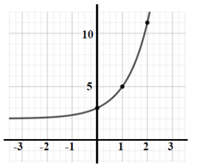**.** 

1. 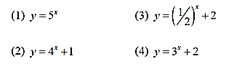

**How do you know?**

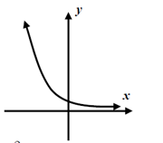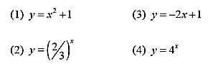





**How do you know?**

Applications: **Percent as Growth or Decay Rates:**

1. At the start of an experiment there are 100 bacteria in a Petri dish. The population is increasing by 20% every day.

1. What is the initial value? __________________
2. What is the rate?_________________________
3. What is the growth factor? And how is it determined?
4. Write an equation representing the total number of bacteria y after x days.
5. Use your equation to determine the total number of bacteria after 60 days.
6. How many days will it take to have 248 bacteria?

Solve graphically showing an appropriate window.

**Depreciation is the decline in an item’s value resulting from age and/or wear. When an item loses about the same percent of its value each year, you can use an exponential function to model depreciation.**

Matt bought a new car at a cost of $25,000.  The car depreciates approximately 15% of its value each year.

1. What is the initial value?
2. What is the **decay** factor for the value of this car?  **(Remember that the decay factor is 1- the rate of change.)**
3. Write an equation to model the decay value y of this car in dollars for x number of years.
4. What will the car be worth in 10 years to the nearest dollar?
5. How many years will it take the car to have a value of $15,353?

Solve graphically showing an appropriate window

**Discovery:**

The number of people who have heard a rumor often grows exponentially. Consider a rumor that starts with 3 people and where the number of people who have heard it doubles each day it spreads.

1. Fill in the table below for the number of people N who knew the rumor after it has spread a certain number of days, d.
2. 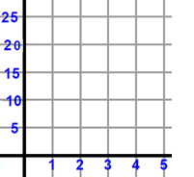Write an exponential equation that represent the relationship between N the number of people who knows the rumor after d number of days.

Number of people N

|  |  |
| --- | --- |
| **d** | **N** |
| 0 | 3 |
| 1 | 6 |
| 2 |  |
| 3 |  |

Number of days d

Name: ____________ Algebra I

**Homework 9-1**: Exponential Unit: Review definitions first; go over Growth and Decay

1. Which of the following represents an exponential function? Justify in a complete sentence.
2. c.

1. d.

2) If

a. b. c. d. 9

3)The breakdown of a sample of a chemical compound is represented by the function p(t) = 300 ${(0.5)}^{t}$, where p(t) represents the number of milligrams of the substance and t represents the time, in years.

* 1. In the function p(t), explain what 0.5 and 300 represent in the contest of the problem in complete sentence.
  2. How many milligrams of the substance is available after 5 years.
  3. Estimate the number of years that will take the substance to decay completely.

4)A construction company purchased some equipment costing $𝟑𝟎𝟎𝟎. The value of the equipment depreciates (decreases) at a rate of 𝟏𝟒% per year.

a. Write a function that models the value of the equipment V(t) over the years (t).

b. What is the value of the equipment after 𝟗 years to the nearest dollar?

|  |  |
| --- | --- |
|  |  |

Real Life Discovery:

1. Write an exponential equation to represent the relationship between y the relative size of the paper after x number of folds.

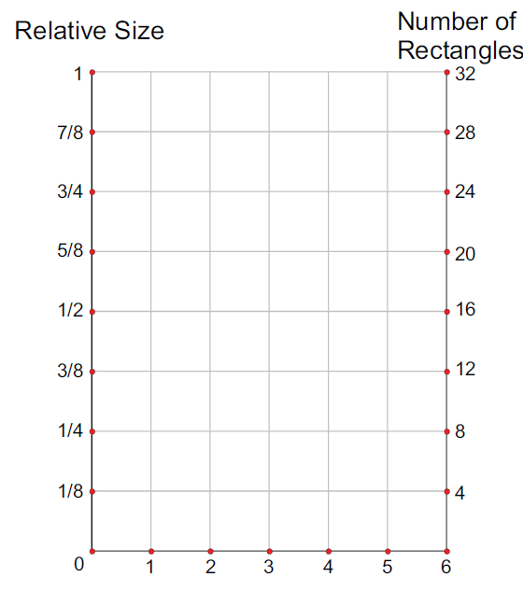

|  |  |
| --- | --- |
| Number of folds x | Relative Size y |
| 0 | 1 |
| 1 | 1/2 |
| 2 |  |
| 3 |  |
| 4 |  |

Relative size y

Number of folds x